STANTONBURY THEATRE

INFORMATION FOR
THEATRE HIRE

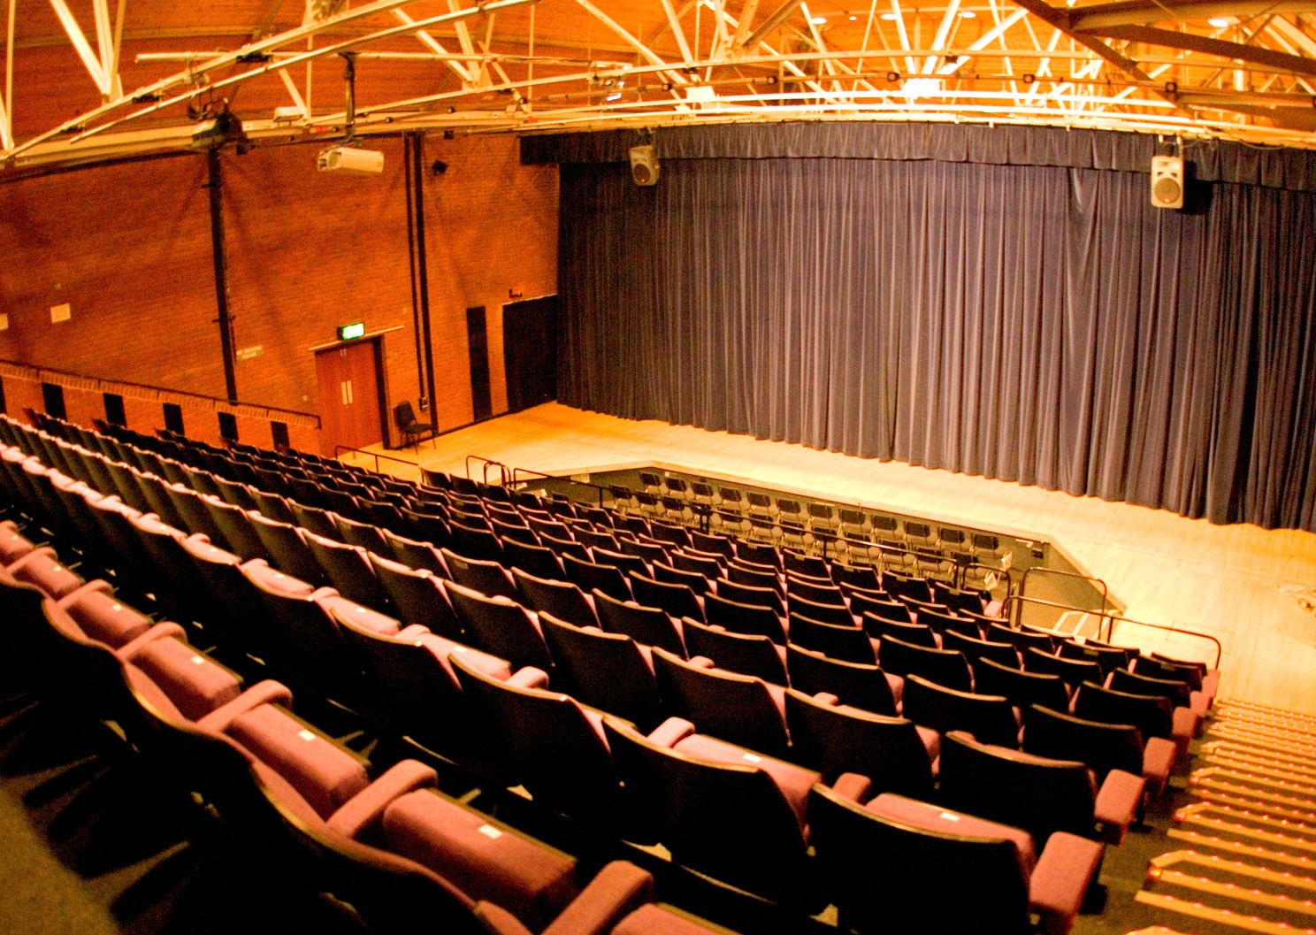

Welcome to Stantonbury Theatre, this information is intended to give you some useful facts if you are interested in hiring the venue.

For more detailed information and to discuss costs and availability please contact the Theatre Administration office on 01908 324422 or email theatre@stantonbury.org.uk

STANTONBURY THEATRE
Stantonbury
Milton Keynes
MK14 6BN

Theatre Hire Administration 01908 324422
Box Office 01908 324466
Email theatre@stantonbury.org.uk www.stantonburytheatre.co.uk

THEATRE PERSONNEL

ARTISTIC DIRECTOR Lucy Cuthbertson
ADMINISTRATOR Vera Lowe
TECHNICAL MANAGER James Tearle

HIRE CHARGES

Please email theatre@stantonbury.org.uk or ring the Administration Office on 01908 324422 and
our current charges will be sent to you

DEPOSIT
On signing the contract to hire the theatre the hirer will pay a non-refundable deposit based on the number of days hire as per the table below.

No of Days Booked | Deposit Required
1 day | £100
1 - 4 days | £200
5 - 7 days | £300
8 days and over | £500

.

CANCELLATION In the event of the Hirer cancelling, the following will apply: -

CANCELLATION PERIOD | AMOUNT DUE
Cancelled within 8 weeks | Full hire fee to be paid less the deposit already remitted
Cancelled within 12 weeks | Pre-paid deposit automatically forfeited by the hirer PLUS 50% of full hire fee (less deposit)
Cancelled within 24 weeks | Pre-paid deposit automatically forfeited by the hirer PLUS 20% of full hire fee (less deposit)
Cancelled within 36 weeks or more | Pre-paid deposit forfeited by the hirer

FRONT OF HOUSE

The theatre will provide A FRONT OF HOUSE MANAGER for each performance. (This service has VAT applied to it)

Hirers must then provide a minimum of 4 designated Auditorium Stewards/Ushers for each
performance who must be over 16 years old.

- Stantonbury Theatre can supply your event with stewards/ushers – however an additional charge (+VAT) per performance will be made and added to your hire charges. Please ask the administrator about this additional service.

There is a bar available for theatre patrons to purchase drinks before and during the intervals of
shows.

The theatre sells ice-cream and confectionery to patrons before and during the intervals of shows

There is FREE car parking adjacent to the theatre.

ACCESS
To assist audience members who are hard of hearing the theatre is fitted with an infra-red hearing
aid system and there are six Sennheiser headsets available.

The backstage area of the theatre is accessible by ramp or by the Dock door at ground level.

Wheelchair access for the auditorium is via an entrance at ground level and there are adapted
disabled toilets adjoining this entrance.

There are four designated spaces in the auditorium for wheelchairs on this same level.

There are several specially marked parking bays for disabled patrons in the car park adjacent to
the theatre. There is the facility to park a van or minibus or specially adapted vehicle close to the
dock door for unloading.

Guide dogs are welcome.

THEATRE TECHNICAL SUPPORT

Get-in, fit-up and get-out times

The days and times booked must include time for rigging the lights, fitting up of the set and
rehearsal time. Because of the demands on the space, get-outs should normally be done immediately after the last performance when Technical Support will be available until 23.30 hours. If it cannot realistically be completed within this time it then it must be booked for the following half day and paid for at an arranged fee.

Technical Support Time

When the Theatre is being used a technician must be on site to supervise and assist. The theatre has a limited number of staff and must comply with statutory health and safety regulations, and accordingly Technical Support is not normally available outside of the hours outlined below.

Non Performance Days | Sunday – Friday from 10.00 to 22.00 hours  The building must be vacated by 22.00 hours so get-ins and rehearsals must finish in sufficient time to ensure this
 | Saturday 13.00 – 22.00 hours – as above
First Performance Day | Sunday – Friday from 10.00 hours - to one half hour after the end of the performance (excepting Get out – see below)
 | Saturday 13.00 hours – as above
Next Consecutive Performance Day(s) | When there is more than 1 performance day, during the remaining performance day(s) in the run, the theatre will be available from a pre-arranged ‘call time’ – not usually more than 2 hours before ‘curtain up’ – to one half hour after the end of the performance

If Hirers overrun their time, ‘out of hours’ charges will be made per hour or part thereof (+VAT).

SEATING PLAN

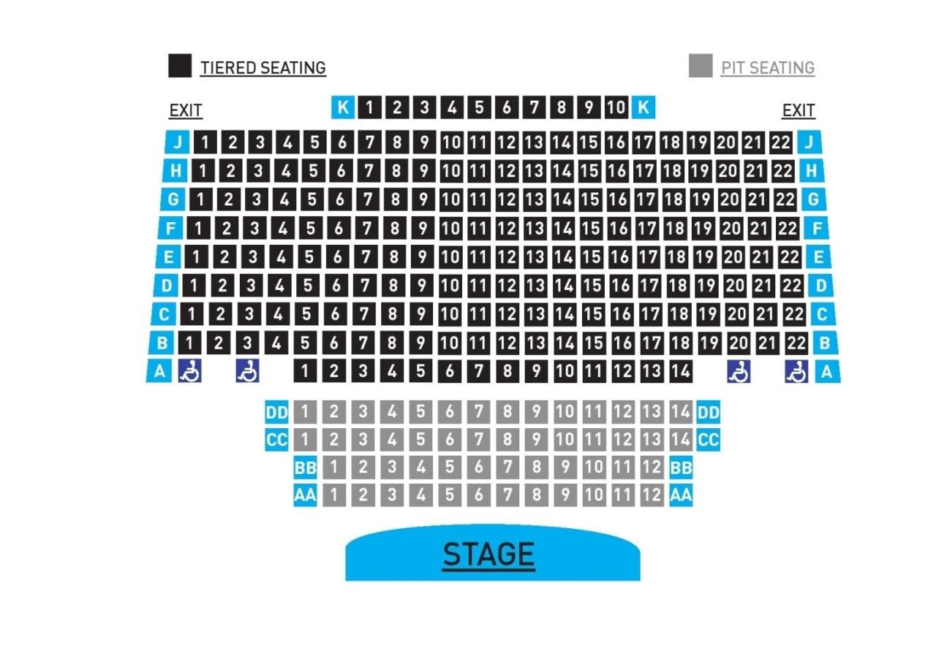

CAPACITY

The Auditorium seats 200 in the fixed raked seating (Rows A-K) + 4 wheelchair spaces.

An additional 52 patrons can be sat in the Pit (Rows AA-DD)

PUBLICITY

The theatre produces a FULL COLOUR brochure which is distributed widely both within Milton Keynes and beyond. This is offered at the discretion of the Artistic Director when the hire represents a contribution to the annual theatre programme at the venue. A charge (+VAT) will be made for this service. This fee also includes full listing and information on the theatre’s website.

